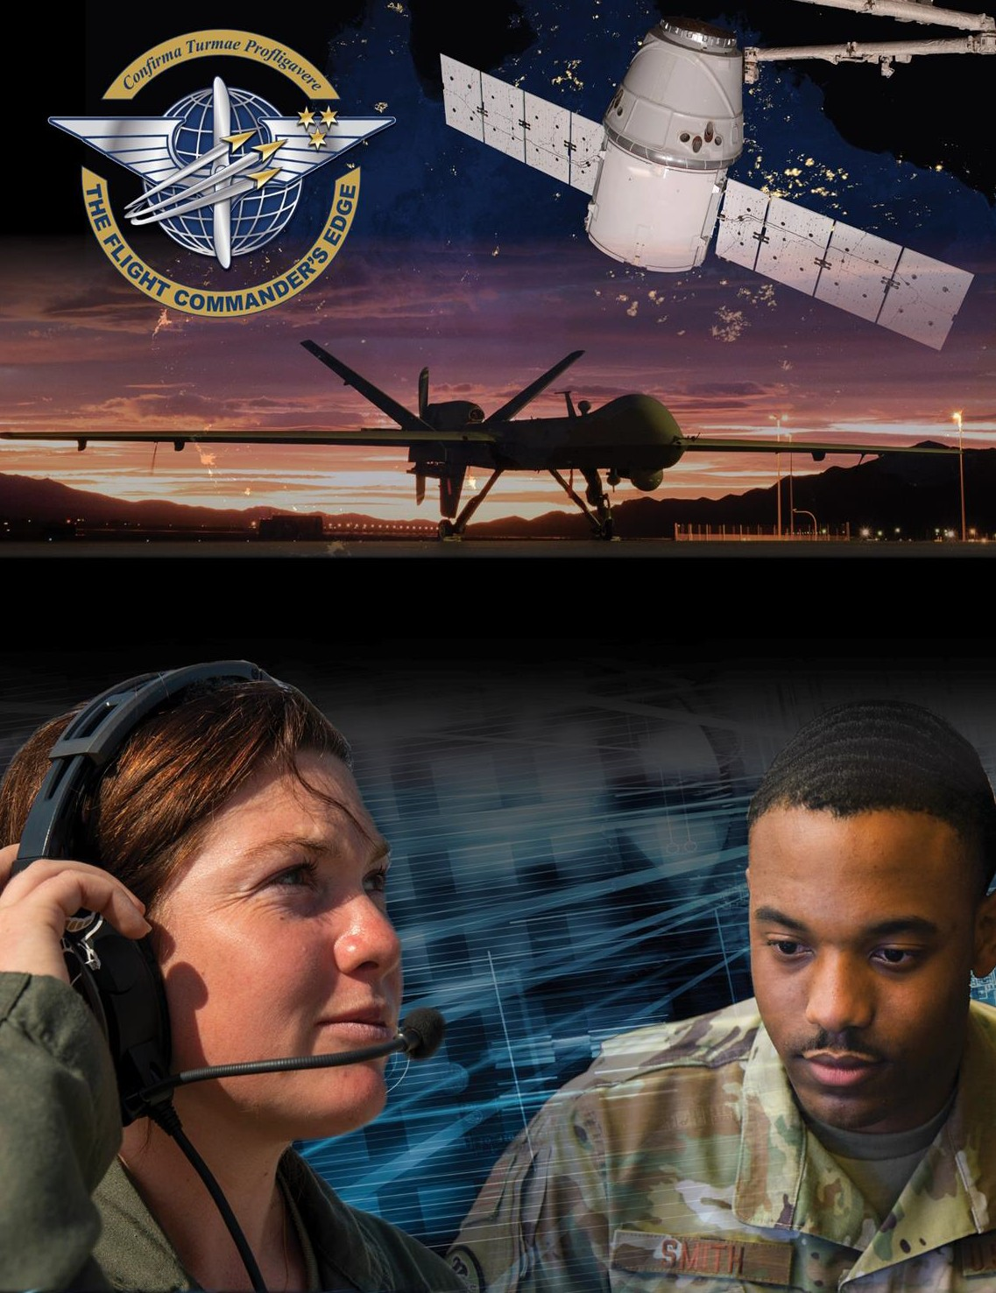

Lesson Guide

Taking Care of Families

***14 April 2025***

# Taking Care of Families

**Purpose**

This lesson guide is designed to support the local development of Flight Commander Leadership Course materials. Selected facilitators should use this guide as they prepare presentation materials. For more information on how lessons are structured, or how to use them in the course, see the ***Course Director’s Handbook*** or online Facilitator Resources.

# Scope

The Department of the Air Force (DAF) families are the backbone of foundational support for our Airmen and Guardians, and an appropriate work/family life balance is crucial for every Airman. The DAF has many programs and base services designed to support families, such as the Key Spouse Program. The Key Spouse program is an official Unit Family Readiness Program designed to enhance readiness and establish a sense of community. Organizations that give attention to and leverage these programs create a resilient environment where Airmen and Guardians and their families feel a sense of stability and support.

As a Flight Commander you not only have to demonstrate an appropriate balance for your Airmen and Guardians, but also encourage it with meaningful communication and follow through to ensure your *team* maintains a proper balance. You should know the programs available to your flight members and their families both at home station and when members are deployed.

You, along with your flight leadership team, are responsible for building and maintaining an environment in which families understand they are valued as part of the team.1

# Recommended Objectives

By the end of this lesson, the participant should be able to:

1. Demonstrate the importance of a healthy work/family life balance.
2. Explain the support agencies and programs available for family members.
3. Describe the Key Spouse Program and its purpose.

# Recommended POC / Presenter

* Squadron-level (or equivalent) leader (DO, CC, Top 3)
* Airmen & Family Readiness Center representative (to possibly augment Sq-level leader)

# Recommended Length:

* 25 minutes (inclusive of questions)

# Recommended Approach

* Informal briefing and discussion

# Lesson Connections

* **Base Support Agencies-**there are multiple services and support agencies that are locally available to assist members and their families. It is important for Flight Commanders to be familiar with these to advise their personnel.
* **Deployment-**deployments are a part of military life and can/will have impacts on family members. Flight Commanders should be aware of this and have a plan in place to help team members and their families through the entire deployment.

# Additional Discussion

The **Key Spouse Program** has a dedicated objective in this course because of its centrality in taking care of families. For detailed information on the Key Spouse Program navigate to the Air Force Personnel Center Key Spouse Program using the browser of your choice.

# References:

1SECAF/CSAF/CMSAF Memo, *Squadron Revitalization Implementation Plan*, 1 June 2018.